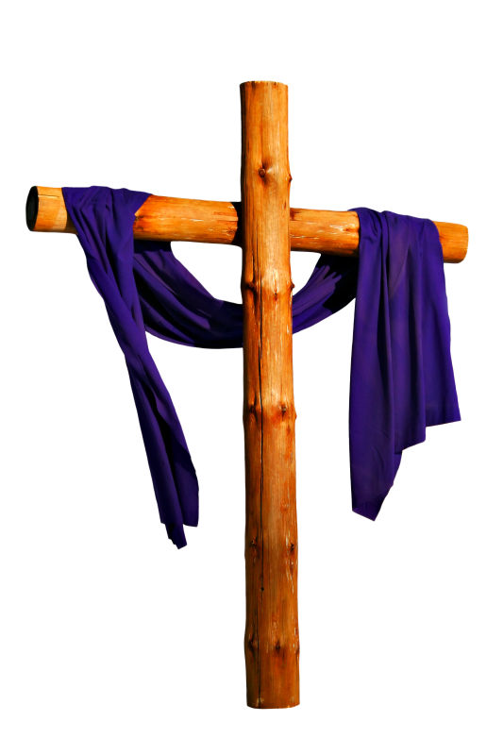
Lent in a Year of Faith: How to Proclaim the Gospel with Power
A Webinar for the New Evangelization
Facilitator: Joe Paprocki, DMin
Tuesday, February 12, 2013
Note-Taking Sheet
- We have the season of Lent for one reason: ___________________________________.
- In order to achieve a dramatic physical makeover, the following 3 things are required:
The spiritual equivalents of these are:
- __________________________
- __________________________
- __________________________
  - ______________________________________
  - ______________________________________
  - ______________________________________

- When it comes to talking about God (doing the work of evangelization), Pope Benedict XVI says that we must recover ___________________________________.

- Examples of the Kerygma – a type of simple, basic, to-the-point, inspiring proclamation of Jesus that was designed to convert hearts and minds are found in this New Testament book ______________________________.
In the world of marketing, these 9 elements can be described as:
  - ________________________________
  - ________________________________
  - ________________________________
  - ________________________________
  - ________________________________
  - ________________________________
  - ________________________________
  - ________________________________
  - ________________________________

- The 9 elements of the Kerygma are:
  - ________________________________
  - ________________________________
  - ________________________________
  - ________________________________
  - ________________________________
  - ________________________________
  - ________________________________
  - ________________________________
  - ________________________________
Proclaiming the Kingdom of God | Proclaiming Jesus as the Way | Jesus’ Mighty Deeds
The Cross of Jesus | The Resurrection of Jesus | The Invitation to Follow Jesus More Closely
Repentance and Forgiveness | Commitment to Christ | Discipleship and Evangelization
www.catechistsjourney.com
www.catechistsjourney.com

