Session 1 Quiz Name ___________________________
Circle the letter for the correct answer.

- God ____________________ himself through Scripture.
  - Hides
  - Reveals
  - Blesses
  - Redeems

- This saint translated the Bible from Greek and Hebrew into Latin.
  - Francis
  - Ignatius
  - Anthony
  - Jerome

- The Bible is the _______________ Word of God.
  - Inspired
  - Partial
  - Hidden
  - Artificial

- The Bible is in two parts:
  - The First Half and the Second Half
  - The Book of Genesis and the Book of Revelation
  - The Old Testament and the New Testament
  - The Liturgy of the Word and the Liturgy of the Eucharist

- The Pope and bishops, who help us understand and interpret the Bible, are referred to as the ___________________.
  - Paschal Mystery
  - Hyperion
  - Magisterium
  - Aquarium

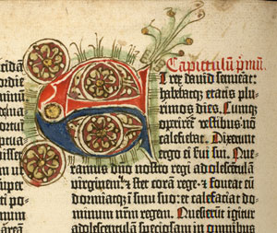
Extra Credit: When the Bible was copied by hand, many copiers used an art form (shown below) known as:

- Illuminati
- Illumination
- Imagination
- Exaggeration

